Revert

What is Revert?
# Source: AI Source: Provided by: [Data Path: Persons Table -> ID Column: 1, Name_En Column: Motasem Essam] -> From: [ChatGPT] on [2/15/2026]
In Git, revert means undoing the effect of a previous commit by creating a new commit that does the opposite changes.
Simple idea
- It does not delete history.
- It adds a new commit that reverses what an older commit did.
- Safe to use on shared/public branches.

Example
# Source: AI Source: Provided by: [Data Path: Persons Table -> ID Column: 1, Name_En Column: Motasem Essam] -> From: [ChatGPT] on [2/15/2026]
If commit A added a line, git revert A will create a new commit that removes that line.
Command
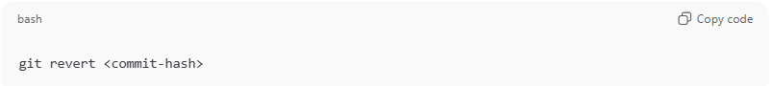
git revert <commit-hash>
What happens
- Git finds the changes introduced by that commit.
- Git creates a new commit that applies the reverse of those changes.
- History stays complete (nothing removed).

Revert vs Reset (important)
# Source: AI Source: Provided by: [Data Path: Persons Table -> ID Column: 1, Name_En Column: Motasem Essam] -> From: [ChatGPT] on [2/15/2026]
- Revert → keeps history, safe for shared repos, creates a new undo commit.
- Reset → rewrites history, can be dangerous if already pushed.

